Global Header + Footer
Wireframe documentation prepared by Jack Reis
September 24, 2012

Table of Contents

1. Global Header 3
1.1. User Interface 3
1.2. Object Table 3
1.3. Searchbar 3
1.3.1. search_bar 3
1.3.1.1. User Interface 3
1.3.1.2. Object Table 3
2. TopNav 4
2.1. User Interface 4
2.2. Object Table 4
2.3. TopNav 5
2.3.1. Home 5
2.3.1.1. User Interface 5
2.3.1.2. Object Table 5
2.3.2. Shop 6
2.3.2.1. User Interface 6
2.3.2.2. Object Table 7
2.3.3. Explore 8
2.3.3.1. User Interface 8
2.3.3.2. Object Table 9
2.3.4. Blog 10
2.3.4.1. User Interface 10
2.3.4.2. Object Table 11
3. Global Footer 13
3.1. User Interface 13
3.2. Object Table 13

Global Header
  - User Interface
  - Object Table
Footnote | Label | Interactions
1 |  | OnClick:  Case 1:  Takes user to sign-in page
2 |  | OnClick:  Case 1:  Takes user to View Cart page
A1 |  | OnClick:  Case 1:  Takes User to Home Page
  - Searchbar
    - search_bar
      - User Interface
      - Object Table
Footnote | Label | Interactions
1 | Search | OnFocus:  Case 1  (If text on widget Search equals "Search"):  Set text on widget Search equal to ""  OnLostFocus:  Case 1  (If text on widget Search equals ""):  Set text on widget Search equal to "Search"
3 | btn - MagnifyingGlass - Search | OnClick:  Case 1:  Searches for the query entered in the search box
- TopNav
OnPageLoad:
Home
(If value of variable TopNav equals "Home"):
Set TopNav state to Home
Shop
(If value of variable TopNav equals "Shop"):
Set TopNav state to Shop
Explore
(If value of variable TopNav equals "Explore"):
Set TopNav state to Explore
Blog
(If value of variable TopNav equals "Blog"):
Set TopNav state to Blog
  - User Interface
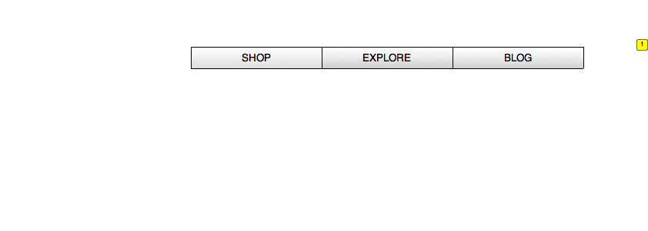
  - Object Table
Footnote | Label | Interactions
1 | TopNav | OnPanelStateChange:  Home  (If value of variable TopNav equals "Home"):  Set TopNav state to Home  Shop  (If value of variable TopNav equals "Shop"):  Set TopNav state to Shop  Explore  (If value of variable TopNav equals "Explore"):  Set TopNav state to Explore  Blog  (If value of variable TopNav equals "Blog"):  Set TopNav state to Blog
  - TopNav
    - Home
      - User Interface
Menu Object
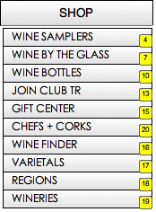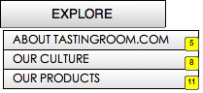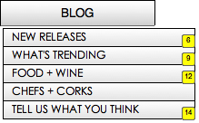
      - Object Table
Footnote | Interactions
1 | OnClick:  Case 1:  Set value of variable TopNav equal to "Shop"  Wait 250 ms  Open Shop in Current Window
2 | OnClick:  Case 1:  Set value of variable TopNav equal to "Explore"  Set TopNav state to Explore  Wait 250 ms  Open Explore in Current Window
3 | OnClick:  Case 1:  Set value of variable TopNav equal to "Blog"  Wait 250 ms  Open Blog in Current Window
4 | OnClick:  Case 1:  Open Wine Samplers in Current Window
5 | OnClick:  Case 1:  Open About TR.com in Current Window
6 | OnClick:  Case 1:  Open New Releases in Current Window
7 | OnClick:  Case 1:  Open Wine by the Glass in Current Window
8 | OnClick:  Case 1:  Open Our Culture in Current Window
9 | OnClick:  Case 1:  Open What's Trending in Current Window
10 | OnClick:  Case 1:  Open Wine Bottles in Current Window
11 | OnClick:  Case 1:  Open Our Products in Current Window
12 | OnClick:  Case 1:  Open Food + Wine in Current Window
13 | OnClick:  Case 1:  Open Join Club TR in Current Window
14 | OnClick:  Case 1:  Open Tell us what you think in Current Window
15 | OnClick:  Case 1:  Open Gift Center in Current Window
16 | OnClick:  Case 1:  Open Wine Finder in Current Window
17 | OnClick:  Case 1:  Open Varietals in Current Window
18 | OnClick:  Case 1:  Open Regions in Current Window
19 | OnClick:  Case 1:  Open Wineries in Current Window
20 | OnClick:  Case 1:  Open Chefs + Corks in Current Window
    - Shop
      - User Interface
Menu Object
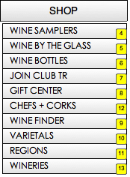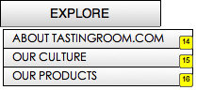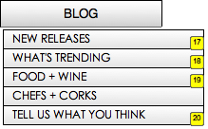
      - Object Table
Footnote | Interactions
1 | OnClick:  Case 1:  Set value of variable TopNav equal to "Shop"  Wait 250 ms  Open Shop in Current Window
2 | OnClick:  Case 1:  Set value of variable TopNav equal to "Blog"  Wait 250 ms  Open Blog in Current Window
3 | OnClick:  Case 1:  Set value of variable TopNav equal to "Explore"  Set TopNav state to Explore  Wait 250 ms  Open Explore in Current Window
4 | OnClick:  Case 1:  Open Wine Samplers in Current Window
5 | OnClick:  Case 1:  Open Wine by the Glass in Current Window
6 | OnClick:  Case 1:  Open Wine Bottles in Current Window
7 | OnClick:  Case 1:  Open Join Club TR in Current Window
8 | OnClick:  Case 1:  Open Gift Center in Current Window
9 | OnClick:  Case 1:  Open Wine Finder in Current Window
10 | OnClick:  Case 1:  Open Varietals in Current Window
11 | OnClick:  Case 1:  Open Regions in Current Window
12 | OnClick:  Case 1:  Open Chefs + Corks in Current Window
13 | OnClick:  Case 1:  Open Wineries in Current Window
14 | OnClick:  Case 1:  Open About TR.com in Current Window
15 | OnClick:  Case 1:  Open Our Culture in Current Window
16 | OnClick:  Case 1:  Open Our Products in Current Window
17 | OnClick:  Case 1:  Open New Releases in Current Window
18 | OnClick:  Case 1:  Open What's Trending in Current Window
19 | OnClick:  Case 1:  Open Food + Wine in Current Window
20 | OnClick:  Case 1:  Open Tell us what you think in Current Window
    - Explore
      - User Interface
Menu Object
      - Object Table
Footnote | Interactions
1 | OnClick:  Case 1:  Set value of variable TopNav equal to "Shop"  Wait 250 ms  Open Shop in Current Window
2 | OnClick:  Case 1:  Set value of variable TopNav equal to "Blog"  Wait 250 ms  Open Blog in Current Window
3 | OnClick:  Case 1:  Set value of variable TopNav equal to "Explore"  Set TopNav state to Explore  Wait 250 ms  Open Explore in Current Window
4 | OnClick:  Case 1:  Open Wine Samplers in Current Window
5 | OnClick:  Case 1:  Open Wine by the Glass in Current Window
6 | OnClick:  Case 1:  Open Wine Bottles in Current Window
7 | OnClick:  Case 1:  Open Join Club TR in Current Window
8 | OnClick:  Case 1:  Open Gift Center in Current Window
9 | OnClick:  Case 1:  Open Wine Finder in Current Window
10 | OnClick:  Case 1:  Open Varietals in Current Window
11 | OnClick:  Case 1:  Open Regions in Current Window
12 | OnClick:  Case 1:  Open Chefs + Corks in Current Window
13 | OnClick:  Case 1:  Open Wineries in Current Window
14 | OnClick:  Case 1:  Open About TR.com in Current Window
15 | OnClick:  Case 1:  Open Our Culture in Current Window
16 | OnClick:  Case 1:  Open Our Products in Current Window
17 | OnClick:  Case 1:  Open New Releases in Current Window
18 | OnClick:  Case 1:  Open What's Trending in Current Window
19 | OnClick:  Case 1:  Open Food + Wine in Current Window
20 | OnClick:  Case 1:  Open Tell us what you think in Current Window
    - Blog
      - User Interface
Menu Object
      - Object Table
Footnote | Interactions
1 | OnClick:  Case 1:  Set value of variable TopNav equal to "Shop"  Wait 250 ms  Open Shop in Current Window
2 | OnClick:  Case 1:  Set value of variable TopNav equal to "Blog"  Wait 250 ms  Open Blog in Current Window
3 | OnClick:  Case 1:  Set value of variable TopNav equal to "Explore"  Set TopNav state to Explore  Wait 250 ms  Open Explore in Current Window
4 | OnClick:  Case 1:  Open Wine Samplers in Current Window
5 | OnClick:  Case 1:  Open Wine by the Glass in Current Window
6 | OnClick:  Case 1:  Open Wine Bottles in Current Window
7 | OnClick:  Case 1:  Open Join Club TR in Current Window
8 | OnClick:  Case 1:  Open Gift Center in Current Window
9 | OnClick:  Case 1:  Open Wine Finder in Current Window
10 | OnClick:  Case 1:  Open Varietals in Current Window
11 | OnClick:  Case 1:  Open Regions in Current Window
12 | OnClick:  Case 1:  Open Chefs + Corks in Current Window
13 | OnClick:  Case 1:  Open Wineries in Current Window
14 | OnClick:  Case 1:  Open About TR.com in Current Window
15 | OnClick:  Case 1:  Open Our Culture in Current Window
16 | OnClick:  Case 1:  Open Our Products in Current Window
17 | OnClick:  Case 1:  Open New Releases in Current Window
18 | OnClick:  Case 1:  Open What's Trending in Current Window
19 | OnClick:  Case 1:  Open Food + Wine in Current Window
20 | OnClick:  Case 1:  Open Tell us what you think in Current Window
- Global Footer
  - User Interface
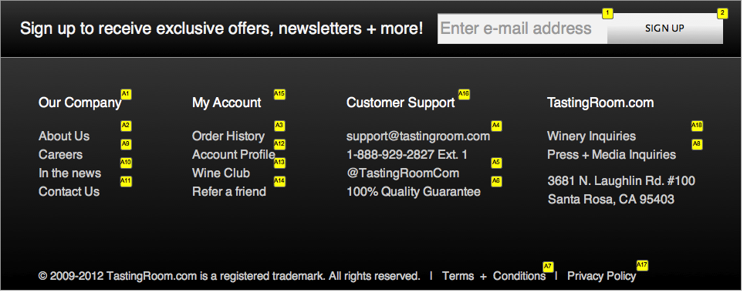
  - Object Table
Footnote | Label | Interactions
1 | textfield | OnFocus:  clear and store label  (If text on widget label storage (ignore) equals ""):  Set text on widget label storage (ignore) equal to text on widget textfield, and  text on widget textfield equal to ""  OnLostFocus:  replace label  (If text on widget textfield equals ""):  Set text on widget textfield equal to text on widget label storage (ignore), and  text on widget label storage (ignore) equal to ""
2 | btn - SignUp - GlobalFooter | OnClick:  Case 1:  Takes user to quick sign-up link with email address pre-populated
A1 |  | OnClick:  Case 1:  Links to page listed in text of footer item
A2 |  | OnClick:  Case 1:  Links to page listed in text of footer item
A3 |  | OnClick:  Case 1:  Links to page listed in text of footer item
A4 |  | OnClick:  Case 1:  Emails support@tastingroom.com (mailto link?)
A5 |  | OnClick:  Case 1:  Links to twitter page
A6 |  | OnClick:  Case 1:  Links to page listed in text of footer item
A7 |  | OnClick:  Case 1:  Links to page listed in text of footer item
A8 |  | OnClick:  Case 1:  Links to Press + Media Inquiries (Mailto to Press + Media alias?)
A9 |  | OnClick:  Case 1:  Links to page listed in text of footer item
A10 |  | OnClick:  Case 1:  Links to page listed in text of footer item
A11 |  | OnClick:  Case 1:  Links to page listed in text of footer item
A12 |  | OnClick:  Case 1:  Links to page listed in text of footer item
A13 |  | OnClick:  Case 1:  Links to page listed in text of footer item
A14 |  | OnClick:  Case 1:  Links to page listed in text of footer item
A15 |  | OnClick:  Case 1:  Links to page listed in text of footer item
A16 |  | OnClick:  Case 1:  Links to page listed in text of footer item… do we have a central Customer Support page?
A17 |  | OnClick:  Case 1:  Links to page listed in text of footer item
A18 |  | OnClick:  Case 1:  Links to Winery Inquiries (Winery.TastingRoom.com?)

